S4584569 Alev AKTURK Tutorial 9

1)Display average wages for all positions.

[SELECT](http://localhost/phpmyadmin/url.php?url=https://dev.mysql.com/doc/refman/5.5/en/select.html) Position_Title, [AVG](http://localhost/phpmyadmin/url.php?url=https://dev.mysql.com/doc/refman/5.5/en/group-by-functions.html#function_avg)(Wage) FROM wages GROUP BY Position_Title

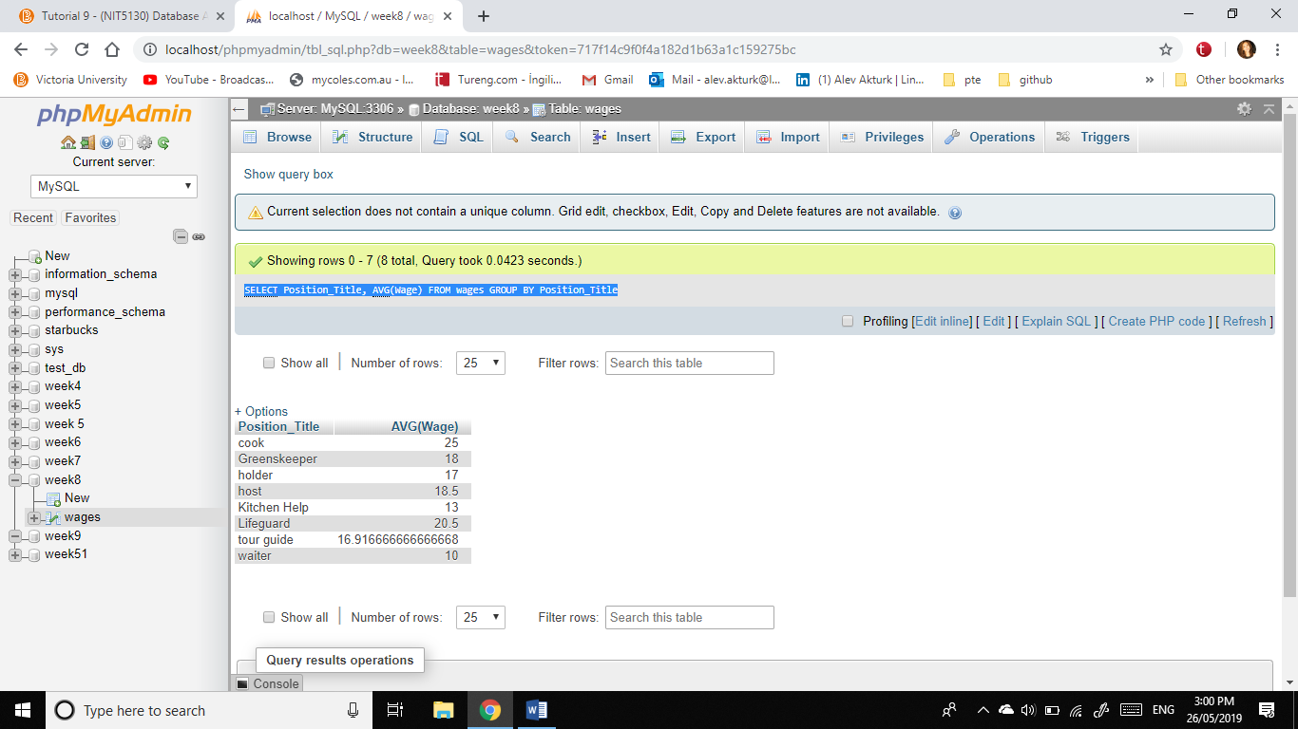

2)Count and display total number of employer from the above database.

[SELECT](http://localhost/phpmyadmin/url.php?url=https://dev.mysql.com/doc/refman/5.5/en/select.html) Position_Title, [COUNT](http://localhost/phpmyadmin/url.php?url=https://dev.mysql.com/doc/refman/5.5/en/group-by-functions.html#function_count)(Employer) FROM wages GROUP BY Position_Title

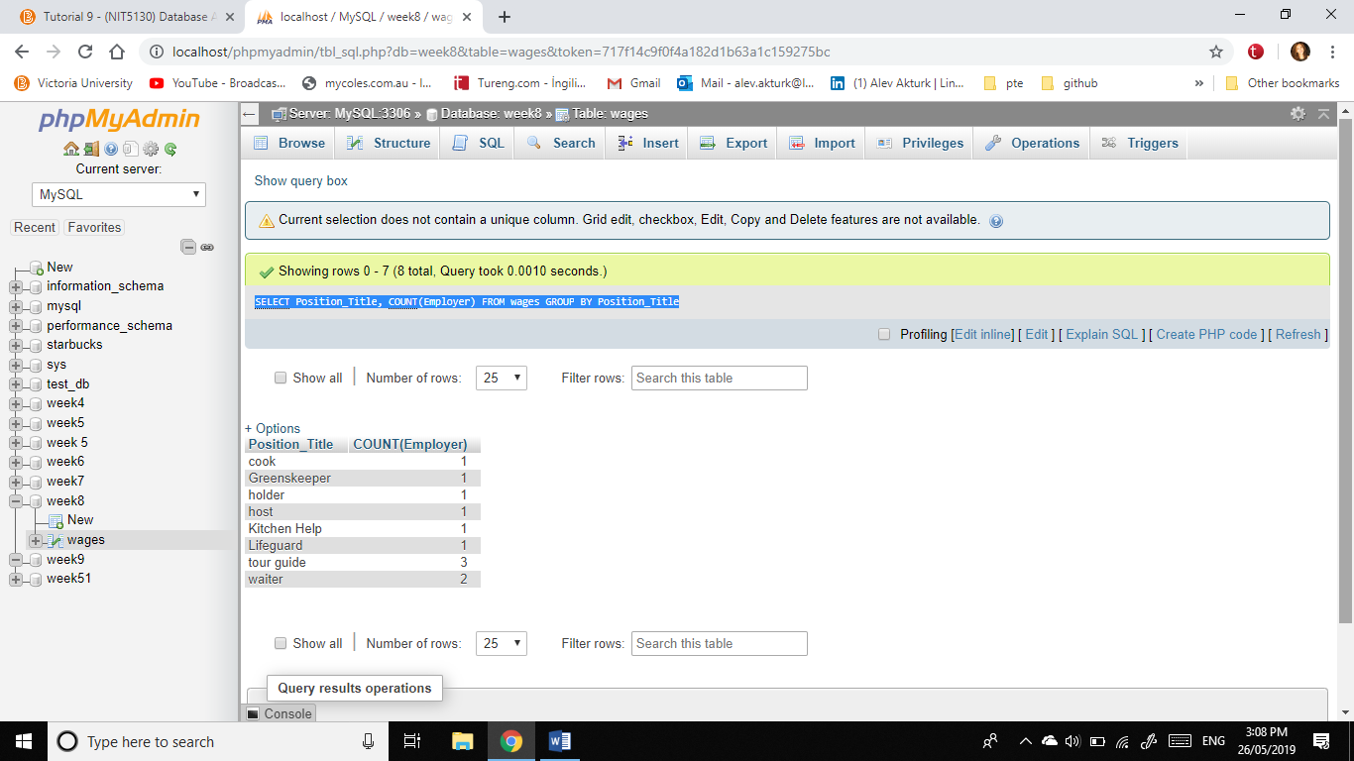

3)Display sum of salary all “tour guide” position title

[SELECT](http://localhost/phpmyadmin/url.php?url=https://dev.mysql.com/doc/refman/5.5/en/select.html) Position_Title,[SUM](http://localhost/phpmyadmin/url.php?url=https://dev.mysql.com/doc/refman/5.5/en/group-by-functions.html#function_sum)(Wage) FROM wages WHERE Position_Title='Tour guide'

